Some Examples of Technical Analysis

Name: Xinyu Lyu(xl422)
RUID: 182007396
Course: Software Engineering
Submission date: 2/8/2017

- Trend lines:
- Trend lines are a just a momentum indicator. We use it to measure the increase/decrease rate of the up/down-trends of the stock price curve. It can give you the signal of any acceleration or deceleration of the trends. And the difference between the trends lines and the other indicators is that it is more intuitive for humans, rather than the complex formulas calculated by our computers.
- Types of trends: uptrend: a slope goes up, downtrend: a slope goes down, sideways trends: the horizontal trends. Figure.1 shows such three trends lines.
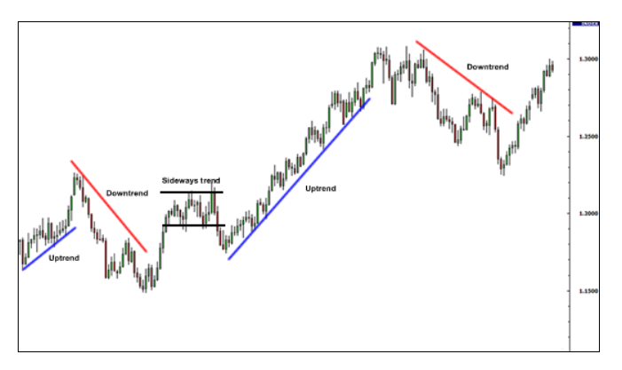
Figure.1
- Scales: Before we start to draw the trend lines, we need to know which scale is applicable to which kind of the time term. There are two widely used scales, the Normal Scale, and the Log Scale. The Normal Scale compares the stock price(y) with the time(x). And the Log scale measures the growth rate against the time. In addition, there are two kinds of time terms. One is the Short Term(monitor 3 years or less) and the other one is the Long Term(more than 3 years). For short-term charts, it is more applicable to use the normal scale and for the long-term ones more for the log ones.
- How to draw: To draw the trend lines, there are some basic rules you should obey. First, draw the up-trend lines through the lows and the down-trend lines through the highs of the price curve. Second, each up/down trend line should be confirmed by going through at least three lows/ups price points on the price curve. In Figure.2, the up-trend line goes through three lows on the price curve. In Figure.3, the down-trend line goes through three highs on the price curve.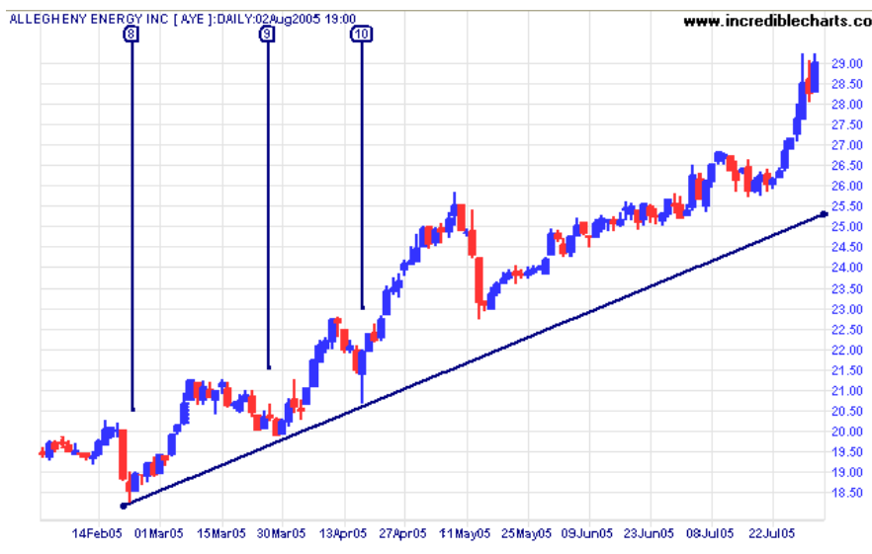
Figure.2
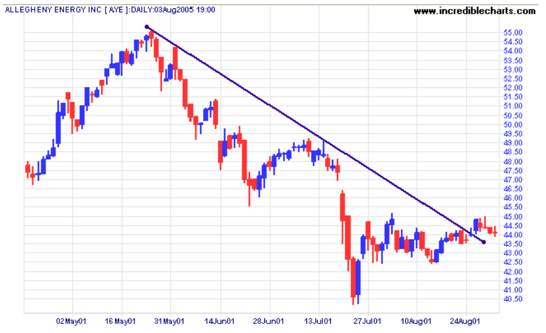
Figure.3
Third, for the long-term chart, trend lines are more effective when drawn with the closing price. In figure.4, the lower trend line was drawn with the daily lows, and the higher one was drawn according to the closing price which is more accurate for us to analyze the momentum of the stock price.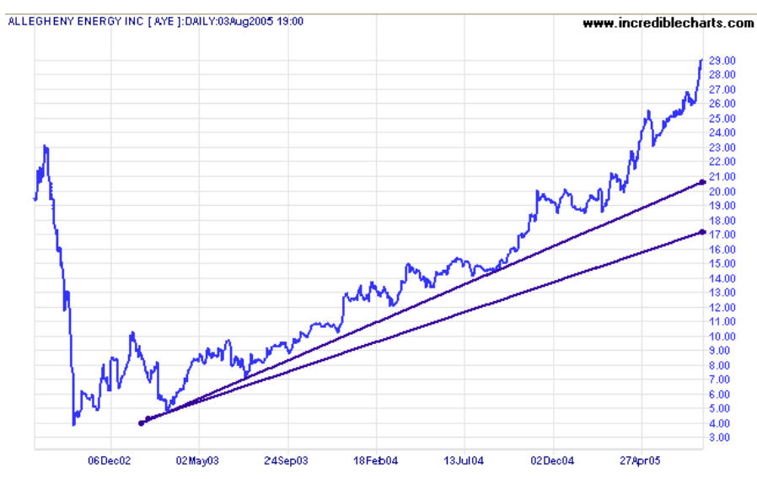
Figure.4
Moreover, the trend line does not have to always touch the lows/highs on the price curve. For any highs/lows on the reversals of the curve, which is close enough to the trend line, can be taken into consideration when drawing the trend lines. For example, in Figure.5 below, all the points 1-8 can confirm the up-trend line.
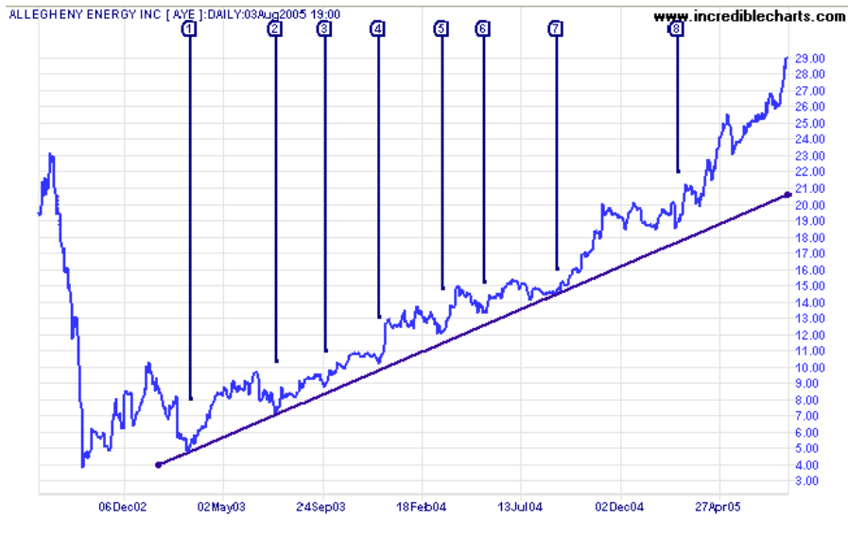
Figure.5
Last but not the least, the trend lines should not cross with the price curve. Moreover, there are some exceptional circumstances that some short term charts may display candles with long tails when the trading was suspended. For example, in Figure.6 below, there is a trading suspended near to Feb.18th in 2005. On such occasion, you need to be cautious with the long suspension periods during which the trend lines might distort sometimes.
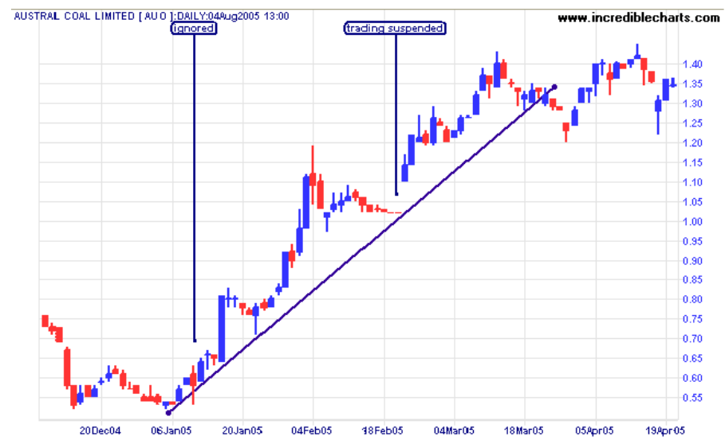
Figure.6
Also, on long term charts, if there is a spike that obviously beyond the overall pattern, you can just ignore it. For instance, shown in Figure.7, on about Nov 1997, the low spike is obviously not fit to the trend line, so you need to ignore it.
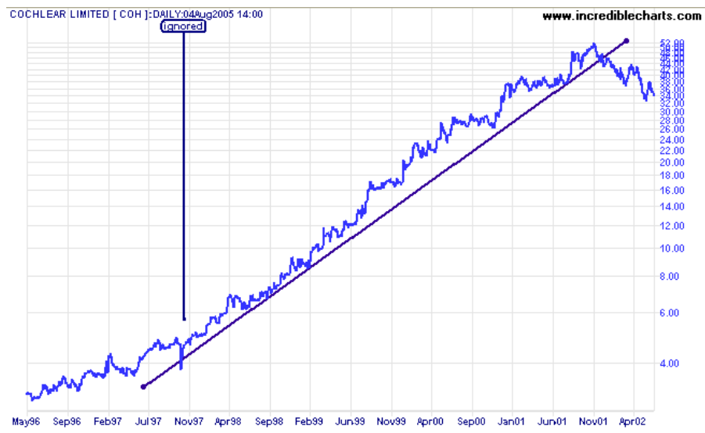
Figure.7
As we mentioned before, the trend lines tell us the rate of increase or decrease of the price curve. So when trend lines break, it means a change in momentum. If the price curve gets steeper at least three times during a short period, shown in Figure.8 below, it can be identified as the blow-off. During such big changes in growth rates, many stockholder will sell their the stocks, meanwhile, many traders will buy such released stocks. Therefore, there might be a huge volume of trades. 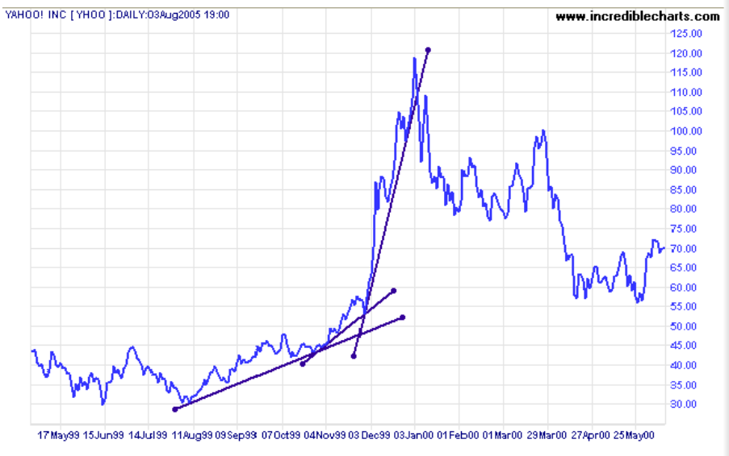
Figure.8
Also, on the long-term charts like Figure.9, the tread-line-break might be an alert of a large volume of trades.

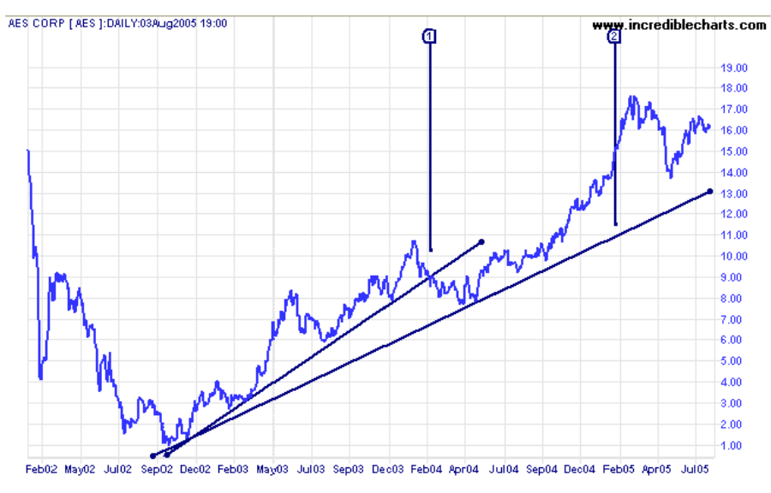
Figure.9

- Channels:
As shown in Figure .10, a channel is created by two parallel trend lines with the same trend kinds. There are three types of channels: up-channel, down- channel and horizon channel.To draw the up channel, first, you need to draw the up-trend line through the lows, then move it up to the position where it can touch the most recent peak of the price curve. And the up-channel is the space determined by the pair of parallel lines. In order to create a down-channel, you need to draw a down-trend line through the highs, then move it down to touch the most recent valley. The down-channel is determined by such pair of lines. The Channels determine the price range for us to make the purchase or sell stocks. For the traders, they may buy the stocks when the price curve touches the lower up-trend line and sell them when the price hit the upper trend line. Therefore, the lower bound of the up channel and the upper bound of the down channel will both trigger a huge volume of trades. 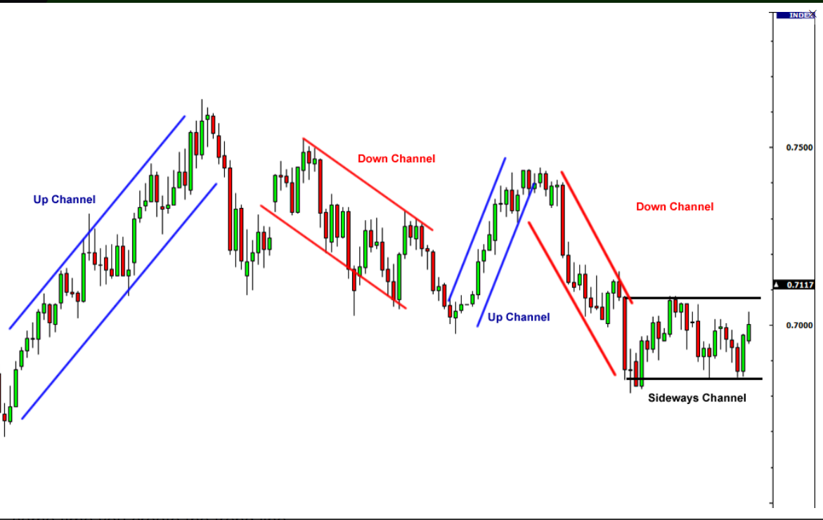
Figure.10
- Support and Resistance:
Support and resistance form the foundation of most chart patterns. And we can identify such levels at any time scale.
- Support level: When the price hits the Support level, buyers are more willing to buy enough amounts of stocks to take control from the sellers.
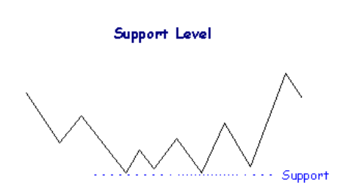
Figure.11
As shown in Figure.11, assume that traders want to buy such a stock. They may wait to buy the stock when the price depreciates to its valley. However, many traders will miss the chance when the price falls to a new low. Because everyone is so weedy that they believe the price will again fall to a much lower level. However, the market has a memory. The price bounces up again. Therefore, the traders who didn’t catch such opportunities will be more inclined to buy the stock when the price returns to that price level. When the price eventually depreciates to that price level, those traders won’t lose the chance at this time and they all want to buy the stock. Then the price will rallies again, for the reason that, the demand of buying exceeds the supply of selling. Therefore, it will reinforce the impression that the price is unlikely to fall further than such price level, and we make it the support level. There is a great volume of trades near the support level. Moreover, the support level will get stronger when there is a larger volume of trades in long-term time.
- Resistance level: When the price hits the Resistance level, sellers are more willing to sell enough amounts of stocks to take control from the buyers.
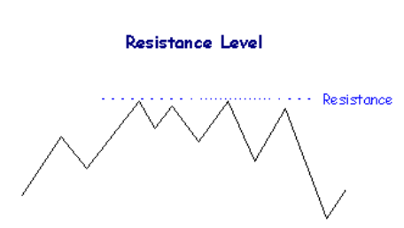
Figure.12
As shown in Figure.12, assume that traders want to sell such a stock. They may wait to sell the stock when its price rises to the peak. However, many of them will miss the chance when the price goes up to a new high level. Because everyone is so weedy that they believe the price will again rise to a much higher level. However, the market has a memory. The price goes down again. Therefore, the traders who didn’t catch such opportunities will be more inclined to sell the stock when the price allies to that price level. When the price eventually rises to that price level, those traders won’t lose the chance at this time and they all want to sell. Then the price will rallies again, for the reason that, the supply of selling exceeds the demand of buying. Therefore, it will reinforce the impression that the price is unlikely to rise up further than such price level, and we make it the resistance level. There is a great volume of trades near the resistance level. Moreover, the resistance level will get stronger when there is a larger volume of trades during the long term.

Reference:
http://www.incrediblecharts.com/technical/trend_lines.php#trendlines-strengths_weaknesses
https://www.babypips.com/learn/forex/channels
http://www.incrediblecharts.com/technical/support_resistance.php
https://money.stackexchange.com/questions/68104/on-what-time-scales-are-stock-support-and-resistance-levels-meaningful

